Here are the latest instructions for setting up the FitNesse and CTP distributions on your system and running the CTP tests. These instructions allow you to execute the CTP tests against the simulator and to debug them from within Eclipse.

Assumptions
- OCAP Reference Implementation (RI) Build Environment – installed on your system and successfully builds the Win32 simulator target configuration. This procedure specifies JDK 1.5 Update 16 or greater as a dependency to build the RI stack and client simulator (ClientSim). This JDK version is also required to run the head-end simulator (HESim). It also installs the Cygwin environment which is used in this procedure to set up a CTP debugging environment.
- OCAP RI Eclipse Project – created in your Eclipse environment and successfully compiles the Java components of the reference implementation. This project is used when debugging CTP tests. There are a couple of procedures documented for creating such a project.
- Subversion Workspace Root – the location on your development system where you check out workspaces from Subversion. This location is represented by “<svn-workspace-root>” in the procedures below.
- Cygwin User Private bin Directory – a private bin directory under your Cygwin home directory for user-defined executables. You may need to uncomment the appropriate lines in your “~/.bash_profile” file to include this directory in your PATH and start a new bash shell.
- Additional Cygwin Installation Packages – ensure that the perl and libxslt Cygwin packages are installed if you plan on attaching the Eclipse debugger to an OCAP CTP test. The libxslt package should also install the libxml2 package as a dependency. These packages are required to preprocess CTP “dot-m” files into .java files from which an Eclipse project can be created.

Install FitNesse & CTP Tests
Use the following procedure to prepare your Windows/XP system with the files needed to run the CTP tests.

- Check out the FitNesse and CTP distributions from Subversion (SVN):
cd <svn-workspace-root>
svn co https://devzone.cablelabs.com/svn/oc/ocap_ri/trunk/ri/ODLCodeDrops
This creates the ODLCodeDrops workspace in “<svn-workspace-root>”.
- Create a “C:\fitnesse” directory on your system.
- Extract the following files from the ODLCodeDrops workspace into the specified locations in the order indicated:
  - Extract “Fitnesse_082708.zip” to “C:\fitnesse”
  - Extract “Fitnesse_082708_Patch.zip” to “C:\fitnesse” and overwrite any existing files
  - Extract “Fitnesse_082708_Patch1.zip” to “C:\fitnesse” and overwrite any existing files
- Update the following line in both “starttestclient.bat” and “restarttestclient.bat” scripts in “C:\fitnesse\testTool\fitnesse” to refer to the location of “ClientSim.bat” in your OCAP RI simulator target configuration directory:
start /d<clientsim-path> ClientSim.bat
Note that “<clientsim-path>” is the absolute Windows path of ClientSim.bat on your system and “/d” is a required command line switch with no spaces separating the switch from the path.
Executing the following command in a bash shell within the OCAP RI build environment displays the correct absolute path in Windows format that you can copy and paste into the scripts:
cygpath -w "$OCAPROOT/bin/$OCAPTC"
- Copy “C:\fitnesse\testTool\clientSim\cssetup\hostapp.properties” to the OCAP simulator configuration usr directory (i.e., “$OCAPROOT/bin/$OCAPTC/env/usr”).
Note that you may need to remove or rename the resulting “hostapp.properties” file or update the class path (VMOPT.0 definition) in mpeenv.ini if you want to do non-CTP work later on. Otherwise, this “hostapp.properties” will prevent the normal one from being found.

Run CTP Tests Using Fitnesse
Use the following procedure to run a CTP test with debugging disabled.

- Ensure the following lines in the client simulator “mpeenv.ini” file are commented out to disable waiting for debugger attachment:
# Uncomment these options to allow the VM to wait for debugger attach
#VMOPT.19=-Xrunjdwp:transport=dt_socket,address=8000,server=y,suspend=y
#VMOPT.20=-Xdebug
- Perform the following steps from a “cmd.exe” shell or just use Windows File Explorer:
  - Navigate to the “C:\fitnesse\testTool\fitnesse” directory.
  - Execute “run.bat” to start the FitNesse HTTP server.
- Use a browser to connect to the Fitnesse server by navigating to “http://localhost”.
- Use the links to navigate to the test you want to run.
- Click on the “Suite” or “Test” button to execute the suite or test. The first time you do this Fitnesse will start the Client Simulator. It is not necessary to shut down the simulator as you run more tests.
A good test to verify the set up once the browser is connected is to navigate to “OCAP Tests” → “SmoketesT” → “Mhptest1” → “ApplicationSignalling505” and click on the Test button. If everything is set up correctly, the client and head-end simulators should start up, the test should execute successfully, and it should pass (i.e., you should see a “green bar” in the browser window). The Client Simulator window should also display a video stream with sound (which can be muted via the simulated remote control).
Hint: You can use the search button on the FitNesse Front Page to search for CTP tests.

Debug CTP Tests Using Eclipse
The OCAP RI stack can be debugged using the source-level Java debugger in Eclipse. The OCAP RI Build Environment creates a client simulator with debug information enabled in the generated executable file and libraries. A slight change the client simulator “mpeenv.ini” file allows Eclipse to remotely attach the Java debugger to a running instance of the simulator. The debugger can be used to step through and inspect stack code.
Note: the CTP tests and associated framework are currently distributed without debug information enabled in the class files. Although you can reliably set a debugger breakpoint at the start of a test, you can not reliably step through the code, nor can you inspect variables defined within the tests. However, once the debugger has stopped at a breakpoint at the beginning of a test, you can set additional breakpoints in the RI stack code and resume running the test to reach those breakpoints.
Note: parts of the CTP test framework are modified by Vidiom to allow the CTP to run within the FitNesse framework. These modifications are not included in the CTP source files exported from the CableLabs ocaptest Subversion repository; however they are included in the corresponding class files contained in the FitNesse zip files in ODLCodeDrops workspace. This disparity can lead to inaccuracies when using the debugger or examining stack dumps.

Prepare the Eclipse Debugging Environment
Use the following procedure to prepare your system to debug an MHP/HAVi CTP test.
- Export the CTP framework and tests from SVN:
cd <svn-workspace-root>
svn export https://devzone.cablelabs.com/svn/oc/ocaptest/tags/CTP_I1_0_1_REL_B
This creates an unversioned CTP_I1_0_1_REL_B directory tree in “<svn-workspace-root>”. The “export” command is used instead of “checkout” since the resulting directory tree will be modified in-place during a later step to remove OCAP “dot-m” tests that are not mature enough for inclusion in the CTP test suite. Using an unversioned directory tree avoids unintentional changes to the Subversion repository.
It's better to export the tagged SVN workspace via the command line utility instead of via Eclipse since it’ll complete more quickly and you’ll be able to monitor the progress better. Enter your DocZone user name and password if requested.
- From within a Cygwin bash shell, extract the CTPTestScripts.zip file from the ODLCodeDrops workspace into your private bin directory:
cd <svn-workspace-root>/ODLCodeDrops
unzip -oa CTPTestScripts.zip -d ~
chmod +x ~/bin/*Tests
The archive contains the ctpTests and extractTests scripts, and the common.shl script library, which generate Java package-oriented directory structures of the CTP tests that can be imported into Eclipse. Enter “ctpTests -?” to display a help message describing the script.
- From within the bash shell, create a symbolic link to the mgen.pl script, as follows, to allow you to run it from any directory:
cd <svn-workspace-root>/CTP_I1_0_1_REL_B/mgen-lite
rm ~/bin/mgen
ln -s `pwd`/mgen.pl ~/bin/mgen
Note: you should repeat this step even when upgrading to a new CTP release – there may be changes to mgen in the new release that are required to preprocess the dot-m files..
- From within the bash shell, run ctpTests as follows:
cd <svn-workspace-root>/CTP_I1_0_1_REL_B
rm –rf ../ocaptest/bin../ocaptest/com ../ocaptest/org
ctpTests –x . ../ocaptest
The script will create the ocaptest directory in “<svn-workspace-root>” and populate it with approximately 6,700 CTP tests. After about 80 minutes (on a 1 GHz processor), the script should complete with results similar to the following:
ctpTests: 2008/08/27 20:08:22: Of 6699 test purpose applications found: 100 existed, 4477 linked, 1926 excluded, 196 preprocessed.
The "-x" option is important in that it causes the script to skip those CTP tests that have been specifically excluded by CableLabs as being incompatible with OCAP specifications (i.e., DVB-specific tests) or have a maturity level < 40 indicating the test is still under development.
The “-M” option can be used to restrict the script to extracting only MHP-HAVi tests. Similarly, the “-O” option can be used to restrict the script to extracting only OCAP tests.
The resulting Java package-oriented directory structure is useful for creating an Eclipse project for remote debugging, but it is not useful for developing or permanently modifying tests since a number of the Java source files were generated from dot-m files.
- From within Eclipse, create a new Java project “CTP Tests” using the existing source in the ocaptest directory.
Note: the following screenshots were made using Eclipse 3.4.0 running on Windows/XP and Eclipse 3.3.2 running on MacOS/X so the example dialog boxes may differ slightly from your system. You may also have to increase the maximum heap memory allocated to Eclipse (“-Xmx” JVM option) due to the number of source files.
  - Select File → New → Java Project. Fill in the project name (e.g., “CTP Tests”), select “Create project from existing source”, browse and select the “<svn-workspace-root>\ocaptest” directory that the ctpTests script just created.
Note: If you’re upgrading to a new CTP release and deleted the bin, com, and org directories in step 4 above, then you can just refresh your existing CTP Tests project instead of creating a new project. You will still have to update the build configuration as described in the following steps.
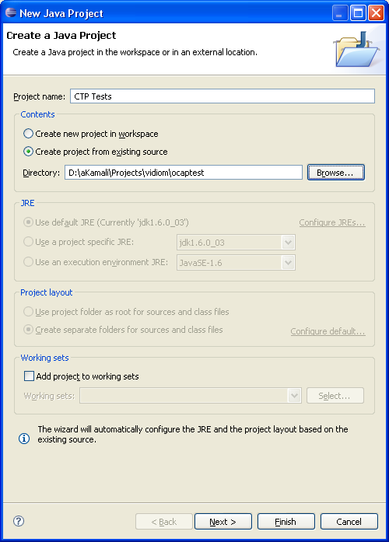
  - Click Next to proceed to the Java Settings dialog. From the Source tab:
    - Expand the “(default package)” and exclude JavaBase.java from the build.
    - Exclude org.cablelabs.test package from the build since it uses Java 5.0 features and has references to Log4J and CheckStyle classes.
    - Add “/bin” to the default output folder path.
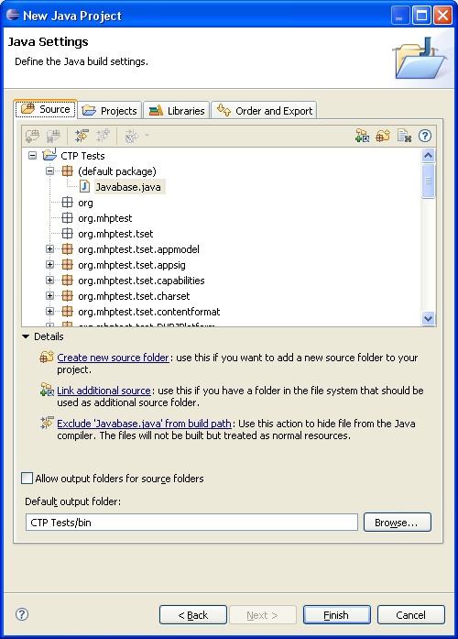
  - From the Projects tab, add your RI project as a required project to allow the debugger to correctly step into the stack code.
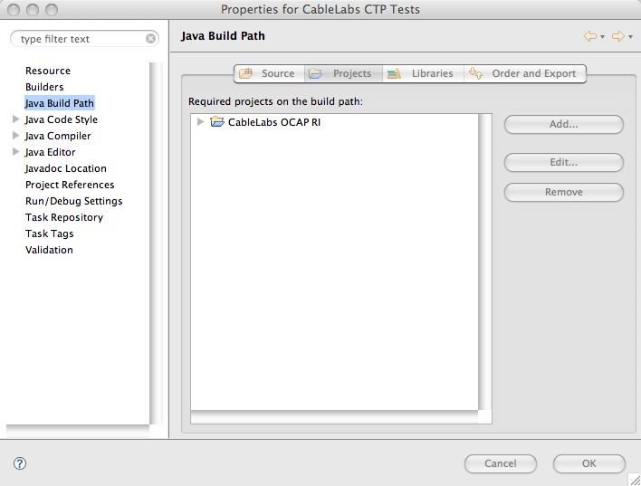
  - From the Libraries tab, click on “Add External JARs” and add “<svn-workspace-root>/CTP_I1_0_1_REL_B/tools/nightly/NITELY_ocap_fmwk.jar” as an external library. Expand the new library entry, select “Source attachment”, and click on Edit to link in the corresponding “NITELY_ocap_fmwk_src.jar” source jar file.
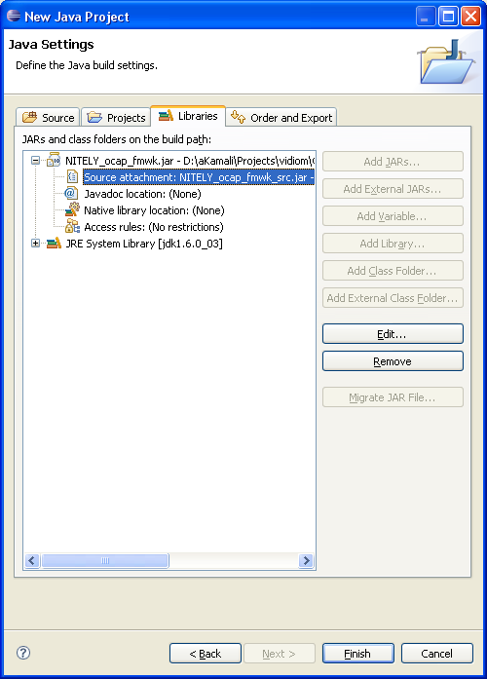
  - From the Order and Export tab, reorganize the project and libraries as shown below to ensure the stack code from the RI projects is accessed before the code in the NITELY_ocap_frmwk.jar file when you step into the stack code.
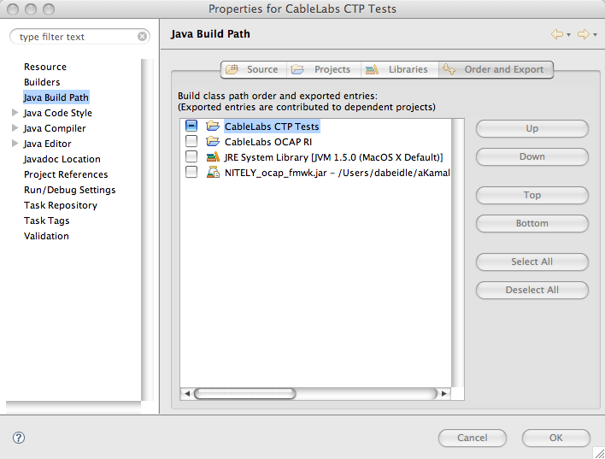
  - Click Finish to finish creating the project and build the workspace.
  - Right click on your new project and select Properties. Select “Java Compiler” and change compiler compliance level to 1.4 to resolve errors from using the keyword “enum” as a variable name. Click OK and rebuild the project.
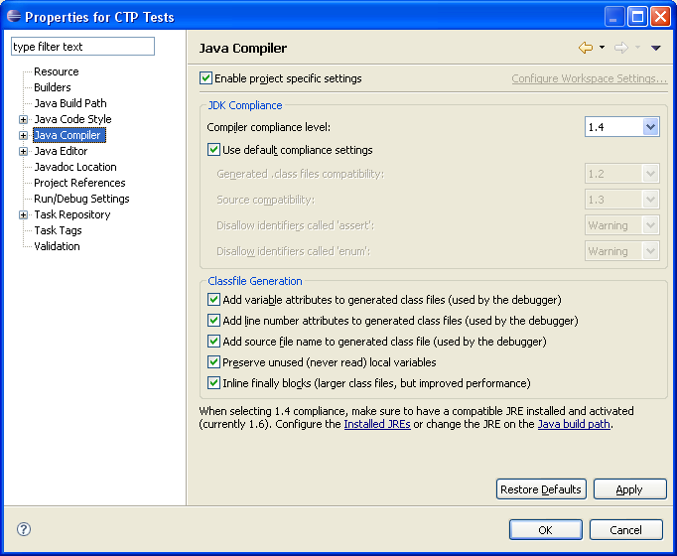
- Within Eclipse, right-click on your new CTP project and select “Debug As” → “Open Debug Dialog…” to create a new debug configuration.
Note that the project names are prefixed with “CableLabs” on the system on which the following snapshots were taken – they are effectively the same as in the prior snapshots.
  - Right-click on “Remote Java Application” and select New.
  - On the Connect tab, ensure the Connection Properties specify “localhost”, or the appropriate IP address of the client simulator, for the Host parameter and “8000” for the Port number.
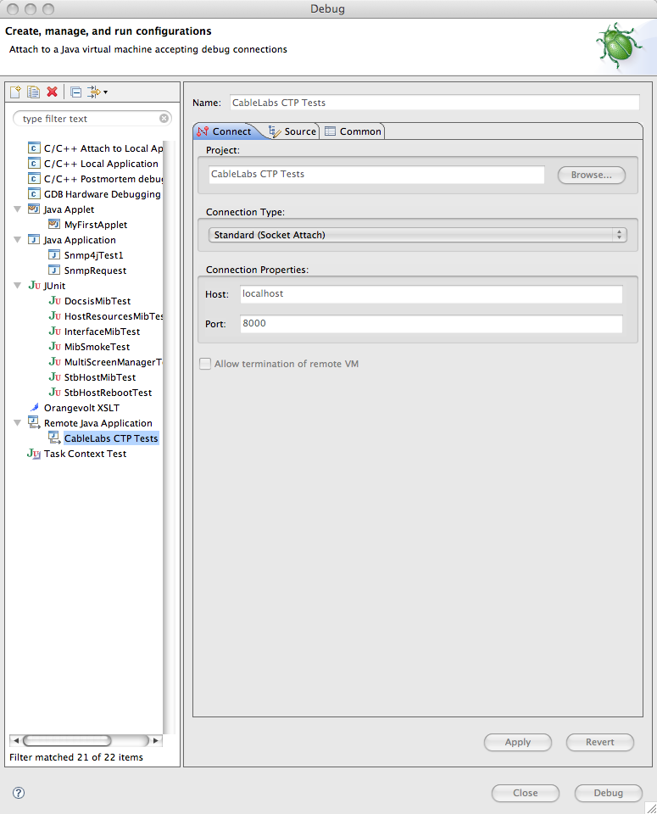
  - Click Apply to accept the changes and Close to close the dialog box.

Debug MHP/HAVi/OCAP CTP Tests Using Eclipse
To debug a CTP test, do the following:
- Modify the client simulator “mpeenv.ini” file to turn on waiting for debugger attachment.
# Uncomment these options to allow the VM to wait for debugger attach
VMOPT.19=-Xrunjdwp:transport=dt_socket,address=8000,server=y,suspend=y
VMOPT.20=-Xdebug
- Find the source for the test you want to debug in the newly-created Eclipse CTP test project, or the RI stack project, and set your breakpoint.
- Re-start the simulator using the steps above for running a CTP test. The simulator will pause until you attach the debug configuration to the simulator.
- Attach the Eclipse debugger selecting the configuration you created above and clicking on Debug. The simulator will resume running until it hits one of the breakpoints you’ve previously established. It may take awhile for the breakpoint to occur since there can be a lot of overhead in initializing the stack, loading the test, and executing it.
You may need to open TCP port 8000 in the Windows Firewall control panel to allow the debugger to attach to the ClientSim process.
Hint: it’s been observed that FitNesse may terminate a test during a debugging session since each test has three minutes to execute before the client terminates it. If you need a longer test timeout, modify the “C:\fitnesse\testTool\emulators\testenvclient_sec\clientconfig.properties” file to change the TIME_SINGLETEST_WAIT definition to a larger value. Then restart the test client or client simulator. This option is available beginning with FitNesse modifications to CTP 1.0.1 Release B.
Hint: if you absolutely need to inspect variables in or step through a test, try copying the .class file from Eclipse’s bin directory to the “C:\Fitnesse\testTool\fitnesse\FitNesseRoot\files\outdir” subdirectory containing same class file and rerun the test. Some success has been reported using this technique.

